# SG Property User Guide

## How to Login to Webmail

1. Open url: <http://genteja.com/webmail>
2. Enter your username/password
3. Click Squirel Mail image

## How to Login to wordpress

1. Open url: http://sgproperty.genteja.com/wp-login.php
2. 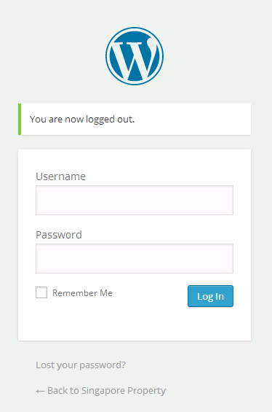
3. Enter your username and password
4. Click Log In button.

## How to Add A Property

1. Click Property on the left panel
2. 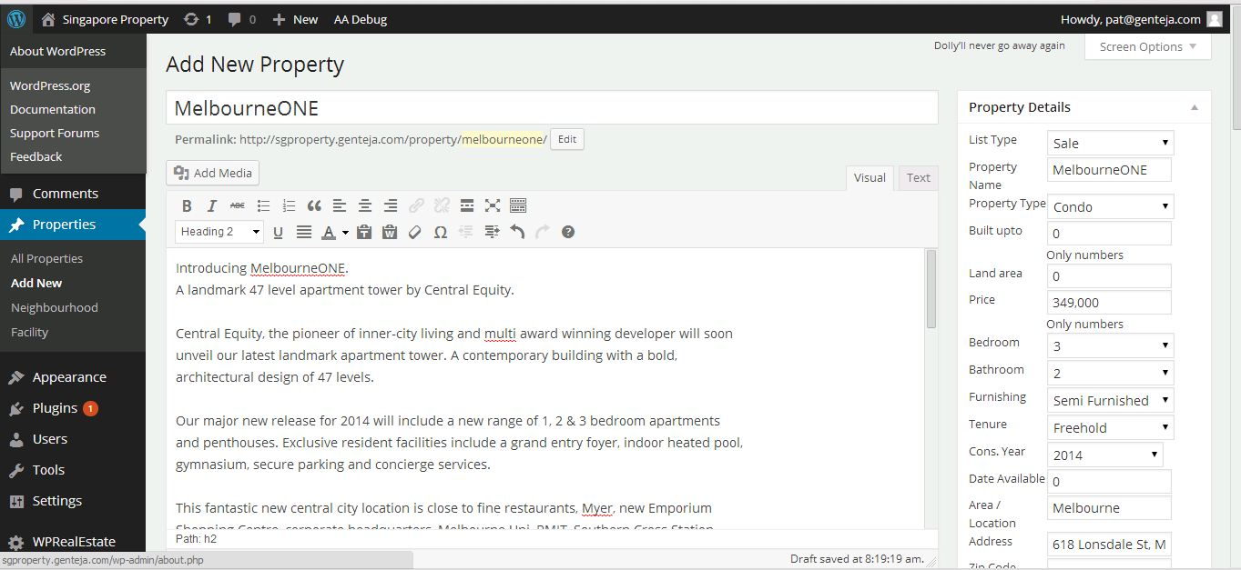
3. Fill up all the details
4. To add property images, Scroll down and click “Add New” link on the bottom right
5. Click “From Computer” Tab, and upload your files
6. 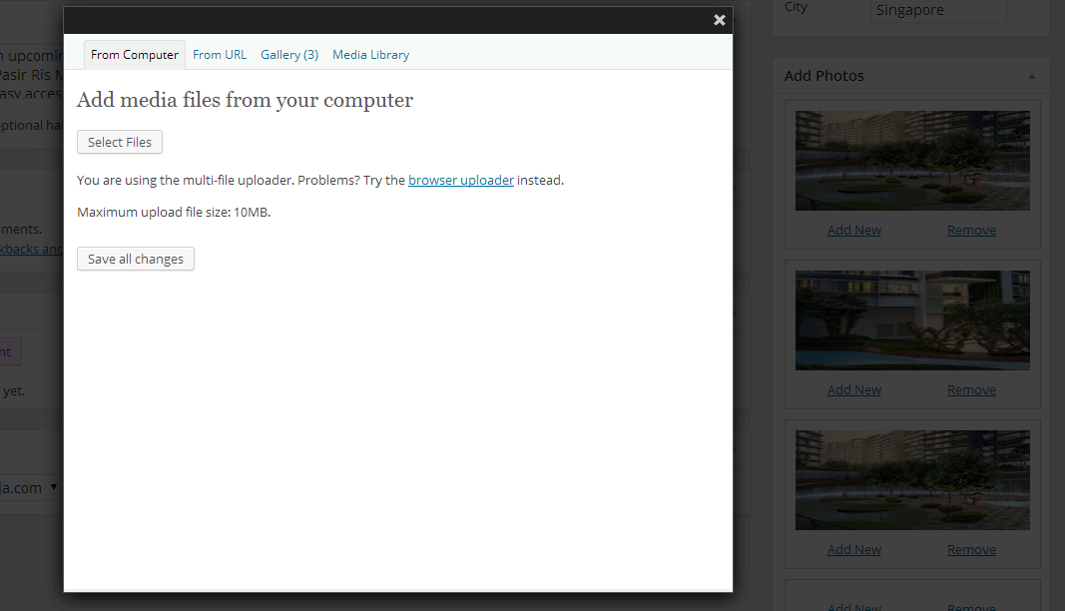
7. Click “Media Library” Tab,
8. Choose your uploaded image,
9. Click “show”
10. 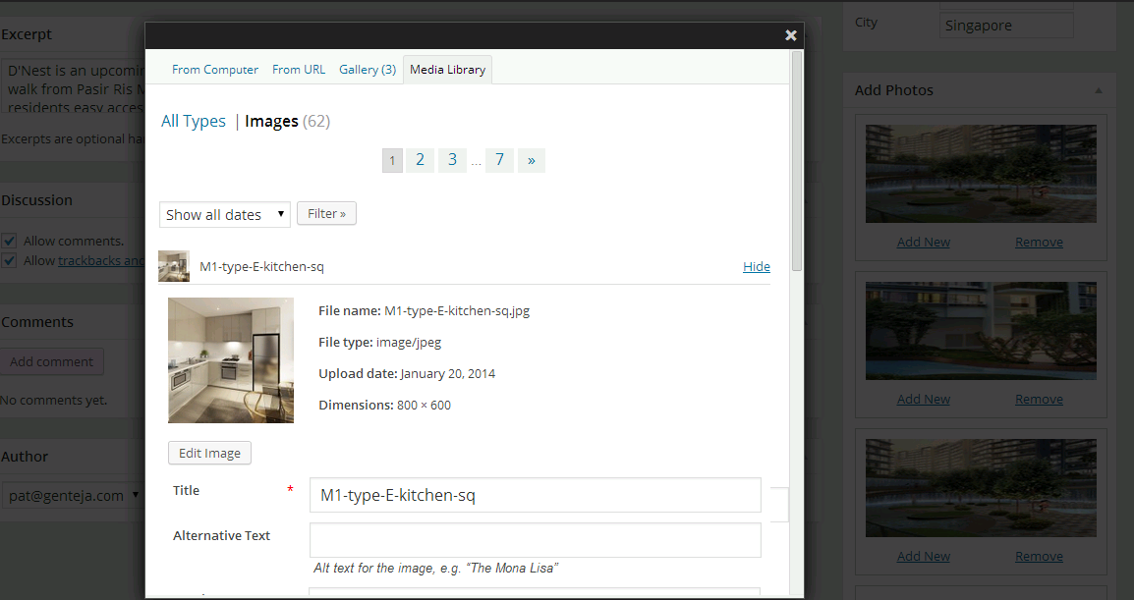
11. Scroll down and Click “Insert into Post”
12. 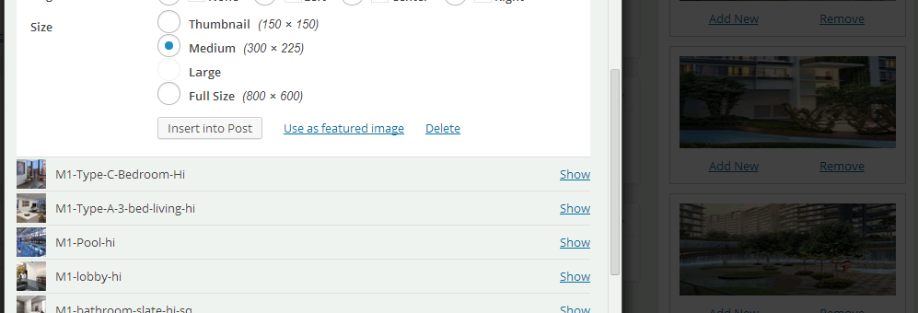
13. Scroll down and click Publish/Update to submit and publish the property
14. 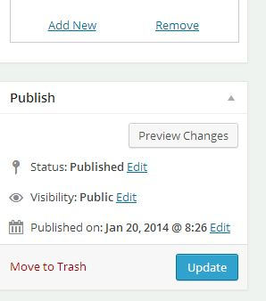

## How to add an Article

1. Click Post on the left side
2. 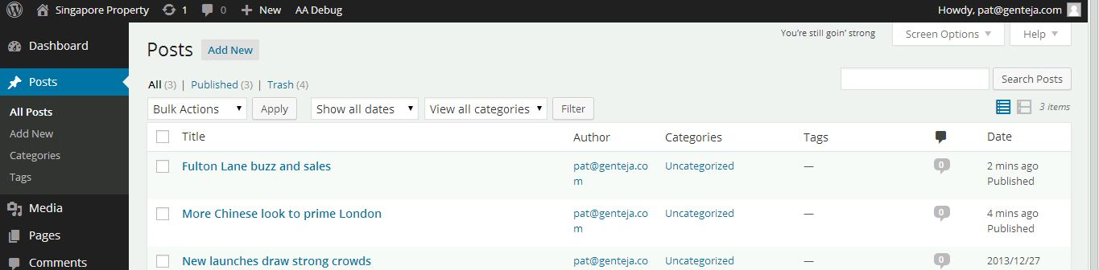
3. Click “Add New” button on the top
4. 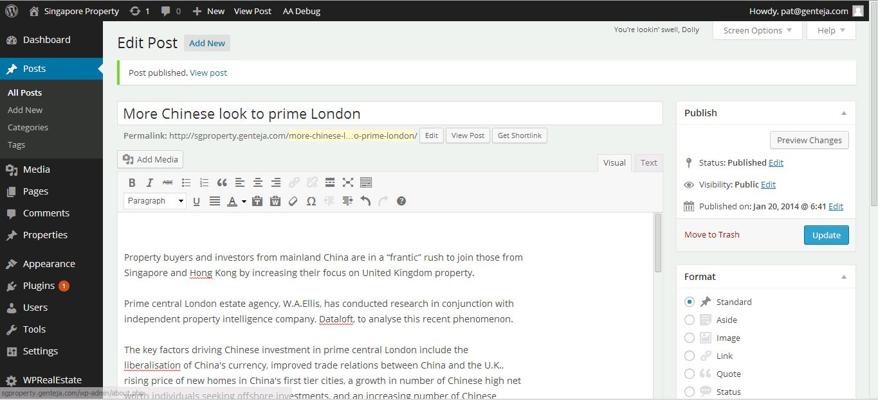
5. Enter your article details.
6. Click Publish / Update on the right panel to publish your article.